Session 1: Version Control with Git and GitHub

1. Objective
To initialize a local project repository, practice basic Git commands, and establish a remote connection to GitHub for the Full Stack Application Development project.

2. Project Details
- Project Name: Project-Hub (Student Project Showcase Platform)
- Course Code: 10213CS224
- VTU: 25299
- Tools Used: Git Bash, VS Code Terminal, GitHub.

3. Task Implementation

Task A: Initialize and Configure Local Repository
- Created a project directory named project_hub on the Desktop.
- Initialized the repository using git init.
- Configured user identity (Username and Email).
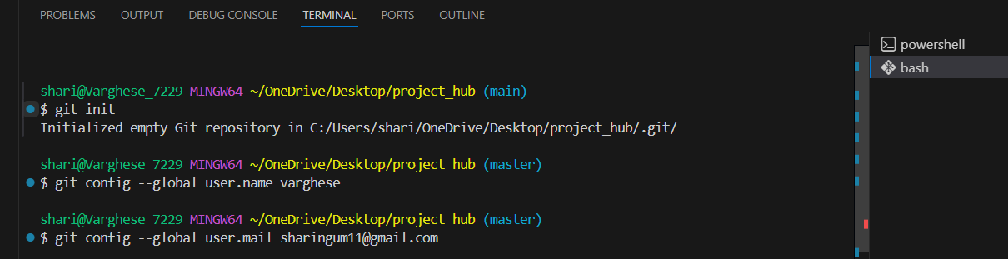

Task B: Basic Git Commands & File Management
- Created a README.md file to describe the project.
- Command used to stage file: git add README.md.
- Command used to commit: git commit -m "README".
- Command used to change branch: git branch -M main.
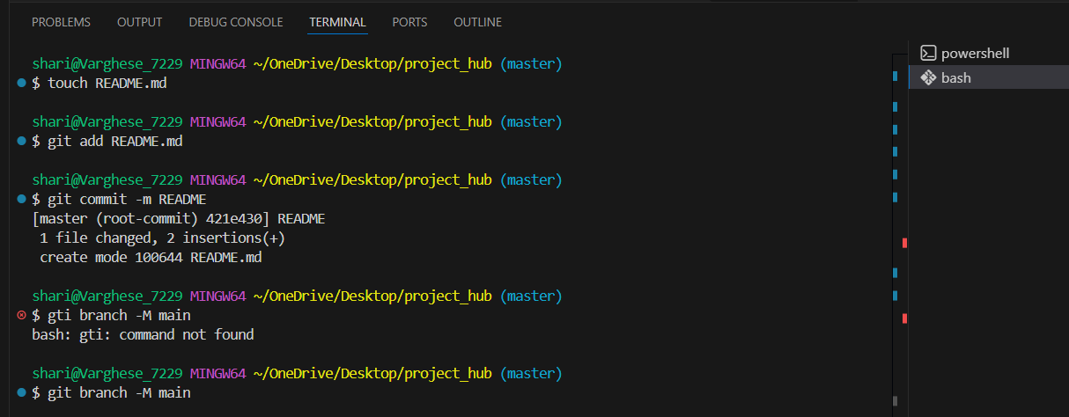

Task C: Remote Connectivity and Push
- Created a new repository on GitHub.
- Linked the local repository to GitHub using: git remote add origin https://github.com/Varghese778/Project_Hub
- Successfully pushed the code to the main branch using git push -u origin main
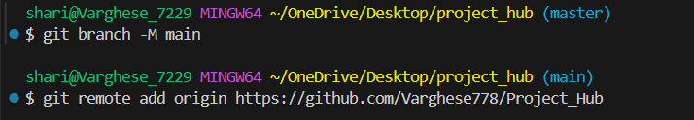
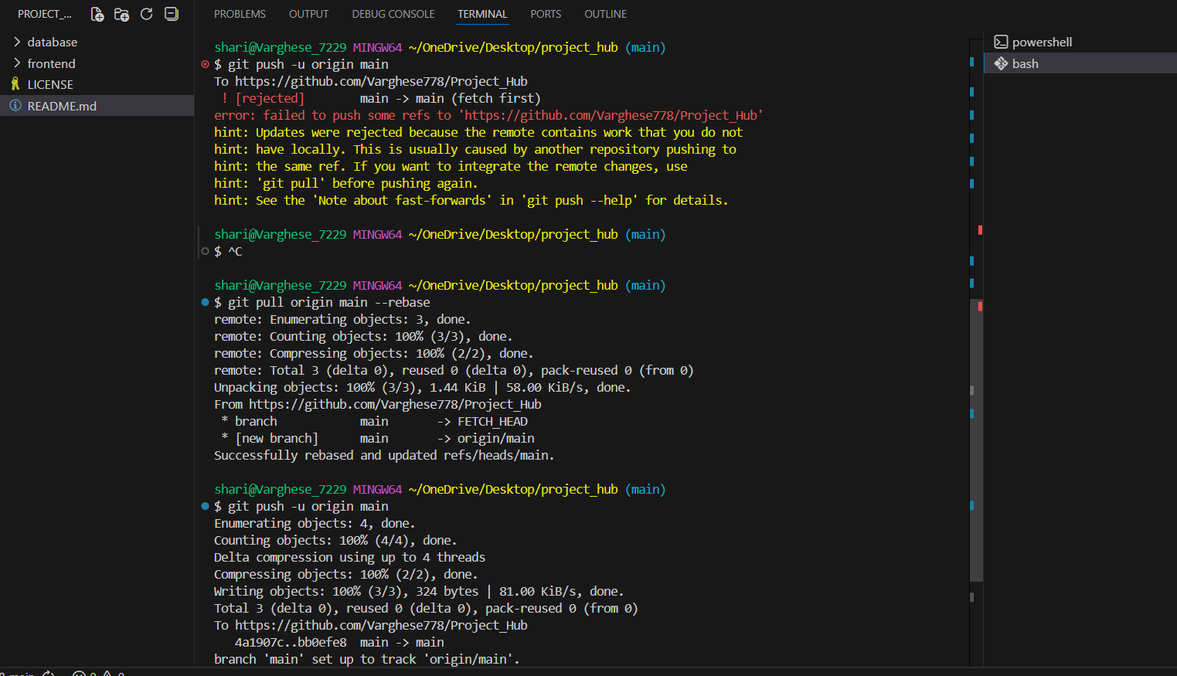

4. Conclusion
The environment for the project is successfully set up. The project files are now tracked under version control, allowing for collaborative development and backup on GitHub.
